All-in-focus image capture using lens swivel

Indranil Sinharoy, Prasanna Rangarajan, Marc P. Christensen

Department of Electrical Engineering, Southern Methodist University, 6251 Airline Road, Dallas, Texas 75275-0338

[isinharoy@smu.edu](mailto:isinharoy@smu.edu), [prangara@mail.smu.edu](mailto:prangara@mail.smu.edu), [mpc@lyle.smu.edu](mailto:mpc@lyle.smu.edu)

**Abstract:** We present a simple technique for synthesizing an infinite DOF image from a sequence of photographs captured while rotating a symmetric lens about the center of the entrance pupil. A Zemax simulation is used to test the method.

**OCIS codes:** (110.0110) Imaging systems; (110.1758) Computational imaging; (110.4190) Multiple imaging;

1. Introduction

Cameras have limited depth of field (DOF): when we photograph a scene, only a finite region of the object space appears sharp in the image as illustrated in Fig. 1. Methods such as focus-stacking, wavefront coding, and plenoptic imaging solve this problem to various degrees. We present a simple method that involves capturing a series of images while rotating a *symmetric* lens pivoted at the center of the entrance pupil; followed by registration and blending, which results in a composite image with infinite DOF. It is curious that this technique has not been discussed before[1].



Fig. 1 DOF problem: (a) Macro photography using a conventional camera. (b) Scheimpflug imaging.

The extent of the DOF depends on the focal length, focus depth, aperture, and pixel size. A large DOF is often desirable in applications such as microscopy (to study evolving processes in 3D), machine-vision (for imaging objects with isotropic resolution), surveillance and general photography.

Before discussing the new method, we review two existing methods related to ours. In focus stacking [1], a form of epsilon photography, a stack of photographs is captured while focusing at intermittent depths. No single photograph has the complete scene in focus, but the stack as a whole contains all parts of the scene in focus. We can generate an image with large DOF by blending the in-focus regions from the photographs in the stack. Another common technique, called Scheimpflug imaging [2], is commonly used to focus on tilted object surfaces. It involves swiveling the lens and/or the sensor about their pivots, which results in the plane of sharp focus (PoSF) to rotate. The direction, amount, and axis of rotation of the PoSF are uniquely determined by the orientation of the lens and sensor planes, the focal length, and the lens-to-sensor plane separation. Thus, we can orient the PoSF along a particular direction of interest resulting in infinite DOF along that direction. However, the DOF along other directions is still finite as shown in Fig. 1(b). In this work, we combined the essential ideas from the two methods discussed to devise a new class of epsilon photography in which the computational image has infinite DOF.

The main idea of this paper is that if we rotate a *symmetric* lens about the center of its entrance pupil, then the homographies between the images formed by the lens rotations are *independent* of the object coordinates. Concomitantly, rotating the lens forces the PoSF to swing through the three-dimensional object space (extending infinitely along the depth). Consequently, we can construct a stack with relatively few images that collectively contain all regions in focus within an infinitely extending depth. Since the inter-image homography is independent of object coordinates, we can easily register and fuse the images in the stack to generate a picture exhibiting infinite DOF.

2. Theory

Fig. 2 shows a thick lens model in which the origin of the coordinate frame $\left\{C\right\}$ pivots the lens. Similarly, the origin of image frame $\left\{I\right\}$ pivots the sensor. Object and image distances are measured from the entrance ($E$) and exit ($\acute{E}$) pupils respectively, which are themselves located at $d_{e}$ and ${\acute{d}}_{e}$ from the lens’ pivot point along the optical axis.

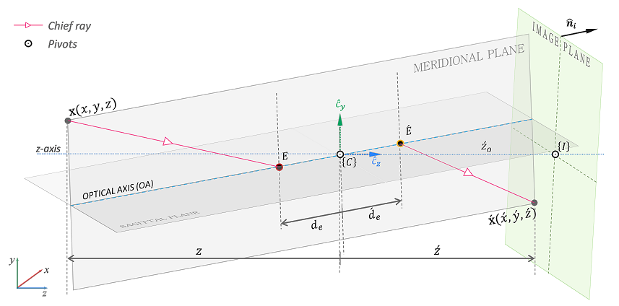

Fig. 2 Imaging model

The geometric relation between a world point $\text{x }$ and its corresponding image[2] , derived in [3], is given as:

|  |  |
| --- | --- |
| $$\acute{\text{x }}={\acute{d}}_{e} r_{l,3}+\frac{\left({\hat{n}}_{i}\left(3\right){\acute{z}}_{o}-{\hat{n}}_{i}^{T}{\acute{d}}_{e} r_{l,3}\right)}{{\hat{n}}_{i}^{T}{}_{ }^{ }{R_{l}}M_{p}{R_{l}}^{T}\left(V\text{x}+d_{e} r_{l,3}\right)}{}_{ }^{ }{R_{l}}M_{p}{R_{l}}^{T}\left(V\text{x}+d_{e} r_{l,3}\right) .$$ |  |

Where, $R_{l}$ is the rotation matrix applied to the lens; $r_{l,3}$, the third column of $R_{l}$, is a unit vector along the optical axis; ${\hat{n}}_{i}$ is the sensor plane normal; $V=diag(1, 1, -1)$; $M_{p}=diag\left(1, 1, m_{p}\right)$, where, $m_{p}$ is the pupil magnification defined as the ratio of the exit pupil to the entrance pupil diameters. For symmetric lenses, $m_{p}=1$.

Rotation of the lens about $E$ results in a shift of the image-field accompanied by a field dependent warp. For a given object point $\text{x}$, the image points ${\acute{\text{x}}}_{m}$ and ${\acute{\text{x}}}_{n}$ observed under two instances of lens rotations are related as:

|  |  |
| --- | --- |
| $$\begin{aligned}{\acute{\text{x}}}_{n}=&\left[\begin{aligned}{}_{ }^{ }{p s R_{l;n}}M_{p}{R_{l;n}}^{T}{}_{ }^{ }{R_{l;m}}M_{p}^{-1}{R_{l;m}}^{T}+\frac{d}{{\hat{n}}_{i}^{ }(3){\acute{\text{z}}}_{o}}\left(r_{l,3;n}-{}_{ }^{ }{p s R_{l;n}}M_{p}{R_{l;n}}^{T}{}_{ }^{ }{R_{l;m}}M_{p}^{-1}{R_{l;m}}^{T}\right){\hat{n}}_{i}^{T} \\ \end{aligned}\right]{\acute{\text{x}}}_{m} \\ \end{aligned}$$ |  |

Where, $p=\frac{\left({\hat{n}}_{i}^{ }\left(3\right){\acute{\text{z}}}_{o}-d{ \hat{n}}_{i}^{T}r_{l,3;n}\right)}{\left({\hat{n}}_{i}^{ }\left(3\right){\acute{\text{z}}}_{o}-d{ \hat{n}}_{i}^{T}r_{l,3;m}\right)}$, $s=\frac{\left({\hat{n}}_{i}^{T}R_{l;m}M_{p}{R_{l;m}}^{T}V\text{x}\right)}{\left({\hat{n}}_{i}^{T}R_{l;n}M_{p}{R_{l;n}}^{T}V\text{x}\right)}$, and $d$ is the distance of the exit pupil from the entrance pupil. According to Eq. (2), the mapping between the two image points (for the same object point) depends on the object coordinates. However, if $m_{p}=1$, then $s=1$ for all $R_{l }$ and ${\hat{n}}_{i}$. Furthermore, if ${\hat{n}}_{i}^{ }={\left[0,0,1\right]}^{T}$; and if the lens rotates only about the x-axis by angle $β$; and if we designate the photograph acquired under no lens tilt as the reference image, then the mapping between the *n*th instance and the reference ($m=0$) is obtained from Eq. (2) as:

|  |  |
| --- | --- |
| $${\acute{\text{x}}}_{n}=\underset{H_{n}}{\underbrace{\left[\begin{matrix}(d\cos{β}-{\acute{\text{z}}}_{o})/(d-{\acute{\text{z}}}_{o}) & 0 & 0 \\ 0 & (d\cos{β}-{\acute{\text{z}}}_{o})/(d-{\acute{\text{z}}}_{o}) & d\sin{β} \\ 0 & 0 & 1\end{matrix}\right]}}{\acute{\text{x}}}_{0}$$ |  |

Eq. (3) suggests that the rotation of the lens causes a vertical shift by $d\sin{β}$ and scaling by $\frac{\left(d\cos{β}-{\acute{\text{z}}}_{o}\right)}{\left(d-{\acute{\text{z}}}_{o}\right)}$ of the image field, but most importantly, the transformation is independent of the object coordinates. This linear mapping allows us to register all the images obtained under lens rotations before blending to generate an all-in-focus image.

3. Simulation

Fig. 3(a) shows a schematic of the simulation we implemented in Zemax. A 24 mm, f/2.5 paraxial thick lens with $m_{p}=1$ was created to simulate the process of imaging three playing cards placed at 800mm, 1000mm and 1200mm from the lens’ vertex. We used PyZDDE [4] to automate the process of tilting the lens about the x-axis between $±6°$ pivoted at the center of the entrance pupil and create a stack of 9 photographs. Fig. 3(b) is the photograph of the scene for $β=-6°$. Observe that the individual images of the three cards were vertically shifted and de-magnified (not apparent in the figure) by the same amount as predicted by Eq. (3). Because the PoSF is tilted, we can see both in-focus and out of focus regions on all three cards. The in-focus regions, detected using a Laplacian of Gaussian (LoG) filter, are shown in Fig. 3(c). The 9 photographs were registered using the homography in Eq. (3) followed by blending the in-focus regions (as measured by LoG) from the photographs in the stack. Fig. 3(d) shows the composite image in which all three cards are in focus. Fig. 3(e) shows the degree of focus on the three planes in the composite image measured using the LoG filter, which is commonly used to automatically detect in-focus regions in focus-stacking.



Fig. 3 Image simulation using Zemax and PyZDDE: (a) Setup. (b) Photograph for $β=-6°$. (c) Focus-measure using LoG filter. (d) Resulting composite image. (e) Focus-measure of composite image.

4. Summary

We demonstrated a new type of epsilon photography for generating an all-in-focus image by fusing a series of images captured under lens rotations. The crux of this simple method hinges on rotating a *symmetric* lens about the center of the entrance pupil. Although it is not prevalent (only 6% of lenses in our survey of 120 imaging lenses from Zemax database had pupil magnification equal to $1±0.01$), symmetric lenses are typically used in Scheimpflug cameras.

5. References

[1] C. H. Anderson, J. R. Bergen, P. J. Burt, and J. M. Ogden, “Pyramid Methods in Image Processing,” RCA Engineer, vol. 29, no. 6, pp. 33-41 (1984).

[2] Jacobson, Ralph, Sidney Ray, Geoffrey G. Attridge, and Norman Axford, *Manual of Photography* (Taylor & Francis, 2000), Chap. 10.

[3] Indranil Sinharoy, Prasanna Rangarajan, and Marc P. Christensen, “model,” xxx, (2016).

[4] Indranil Sinharoy et al., PyZDDE: Release version 2.0.2. Zenodo. [10.5281/zenodo.44295](http://dx.doi.org/10.5281/zenodo.44295) (2016).

1. To the best of our knowledge.
2. In this model, the image point is defined as the point of intersection of the chief-ray from $\text{x }$ with the image plane.